PIZZA SALES SQL QUERIES

1. **KPI’s**
2. Total Revenue:

Select SUM(total_price) As Total_Revenue From pizza_sales

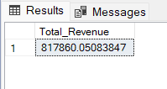

1. Average Order Value:

Select SUM(total_price) / COUNT(DISTINCT order_id) As Avg_Order_Value From pizza_sales

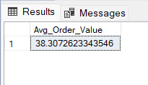

1. Total Pizza Sold:

Select SUM(quantity) As Total_Pizza_Sold From pizza_sales

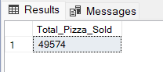

1. Total Orders:

Select COUNT(DISTINCT order_id) As Total_Orders From pizza_sales

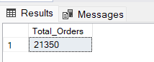

1. Average Pizzas Per Oder:

Select CAST(CAST(SUM(quantity) As DECIMAL(10,2)) /

CAST(COUNT(DISTINCT order_id) As DECIMAL(10,2)) As DECIMAL(10,2)) As Avg_Pizza_Per_Order

From pizza_sales

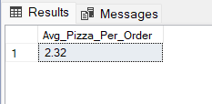

1. **Daily and Monthly Trend**

SELECT DATENAME(DW, CONVERT(DATE, order_date, 103)) AS Order_Day, COUNT(DISTINCT order_id) AS Total_Orders

FROM pizza_sales

GROUP BY DATENAME(DW, CONVERT(DATE, order_date, 103));

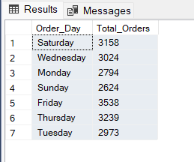

1. **Monthly Trend for Orders**

SELECT DATENAME(MONTH, CONVERT(DATE, order_date, 103)) AS Month_Name,

COUNT(DISTINCT order_id) AS Total_Orders

FROM pizza_sales

GROUP BY DATENAME(MONTH, CONVERT(DATE, order_date, 103));

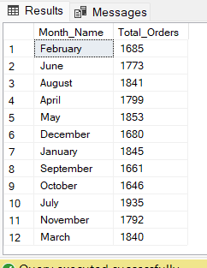

1. **% of Sales by Pizza Category**

Select pizza_category, CAST(SUM(total_price) As DECIMAL(10,2)) As Total_Revenue,

CAST(SUM(total_price) * 100 / (Select SUM(total_price) From pizza_sales) as DECIMAL(10,2)) As PCT

From pizza_sales

Group By pizza_category

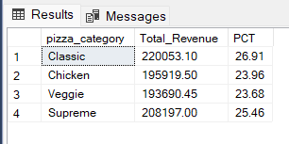

1. **% of Sales by Pizza Size**

Select pizza_size, CAST(SUM(total_price) As DECIMAL(10,2)) As Total_Revenue,

CAST(SUM(total_price) * 100 / (Select SUM(total_price) From pizza_sales) as DECIMAL(10,2)) As PCT

From pizza_sales

Group By pizza_size

Order By pizza_size

